DEPARTMENT OF CHILDREN AND FAMILIES
Division of Early Care and Education

Client Investigation Recommendation
Error Established
Recover Overpayments pursuant to 49.195(3)
Intentional Program Violation Request
Technical Assistance Letter
Close Investigation
General Case Demographics
Name-Primary Person on Case |  |  | D.O.B. | Case Number
Date | Completed By (Name & Worker ID) |  |  | County
BRITS Referral Number |  | Child Care Benefit  Benefit Reduction Suspension of Eligibility No Change

Reason for this Violation/Overpayment:

Agency misapplied program policy
Benefits continued during fair hearing
Collusion between the parent and child care provider
Duplicate Benefits
Failure to provide accurate information for benefits
Agency failed to budget earned income
Agency failed to budget accurate household members
Agency failed to budget unearned income
Failure to report correct child placement
Failure to report child/spousal support income
Provided false documentation or identification
Failure to report household income exceeding program limits
Failure to report accurate household members
Failure to report incarceration
Failure to report assets
Failure to report move out state/change of residence
Failure to report accurate self-employment income/expenses
Non-qualified employer for child care assistance
Provider/parent residing together
Misrepresentation of or failure to report earned income
Misrepresentation of hardship
Misrepresentation of Approved Activity Search
Reporting incorrect or not reporting change in child care need
Trafficking misuse
Utilized child care while not in an approved activity
Other

Due To:
Administrative Error
Client Error

1st Intentional Program Violation
2nd Intentional Program Violation
3rd Intentional Program Violation

Previous IPVs Issued Summary (If Applicable)
First IPV (1R) Overview
IPV Issuance Date:
IPV Sanction Period: –
IPV Reason(s):
IPV Summary of Findings:
Appealed? Appeal Outcome:
Decision Number:
Appeal Details:

Second IPV (2R) Overview
IPV Issuance Date:
IPV Sanction Period: –
IPV Reason(s):
IPV Summary of Findings:
Appealed? Appeal Outcome:
Decision Number:
Appeal Details:

Summary of Investigation Finding

Investigation Timeline

Recommendation

Sources of Supportive Evidence

Contractor | Voting Records | Surveillance
Client Interview | Wage Reports | Employer Interview
Credit Reports  Landlord Contact  Lease/Housing Doc.  Other: | Social Media  Child Support Agency  SUITES  Other State Department  (Specify): | Employment Verification of  Earnings (EVFE)  CLEAR

Overpayment Results
Date Entered | BRITS Referral Number | Claim Number | Overpayment Period | Amount | Error Type
Total Over payment Amount:

Submit this form to childcare@wisconsin.gov to begin the approval procedure. If this request was for an IPV, they/it will be reviewed on a biweekly basis. Once the IPV has been approved, you may proceed to enter the information into the CARES Worker Web (CWW) and the Benefit Recovery (BV) system (as applicable).
If you need Technical Assistance with the investigation or with the completion of this form, please contact: childcare@wisconsin.gov.

Client Investigation Recommendation Form Instructions
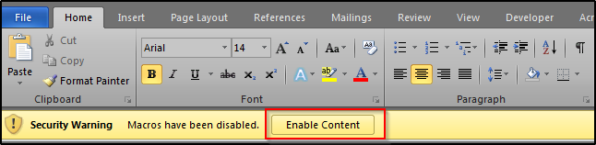
Client Investigation Recommendation
- Recommendation: investigator will identify the outcome of the investigation
- Error Established – no overpayment
- Recover Overpayments – overpayment identified
- Intentional Program Violations Request – IPV, these are submitted to the TA Mailbox for approval; a Client IPV meeting will be scheduled for second and third IPVs for review and approval
- Technical Assistance Letter – formal technical assistance provided; this can be checked in relation to other recommendations
- Close Investigation – case closure would be checked for all cases to indicate these are all final findings for the case
General Case Demographics
- Name of Primary Person on Case: Enter the name of the primary person on the case that the IPV is concerning.
- D.O.B: Enter the date of birth for the primary person.
- Case Number: Enter the Case Number from CWW or EBT CSAW for the individual that the IPV is concerning.
- Date: Enter the date that the individual is completing the request form.
- Completed By (Name & Worker ID): Enter the name and the Mainframe ID of the worker completing the IPV Request Form.
- County/Agency: Enter the agency, county, and/or tribe the primary person under investigation resides in.
- BRITS Referral Number: Enter the BRITS Referral Number that pertains to this referral. For information on where to locate this, please consult the BRITS User Guide.
- Child Care Benefit: Indicate the result the investigation had on the client’s child car benefit:
- Benefit Reduction
- Suspension of Eligibility (IPV)
- No Change
- Reason for the Violation/Overpayment: Select as many reasons as needed that describe the reason for the violation or overpayment discovered
- Due To: Select the reason for the violation or the overpayment from the list available
  - If this is being completed for an IPV, select the box indicating whether this is a first time IPV for the client, a second IPV, or third IPV. This number can be located on the CWW Child Care IPV Penalty Summary Page
  - If there is no previous IPV, no IPV will be listed, and the 1st IPV box should be selected.

Previous IPVs Issued Summary
- First IPV (1R) Overview: Any time that an investigator wishes to pursue a second or third IPV for a client, a summary of the previously issued IPV is required. Please supply the following information regarding the first and/or second IPV issued to the client:
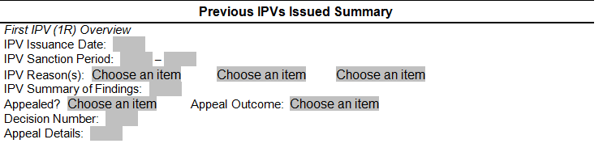

  - IPV Issuance Date: Record the date that the IPV was first entered in CWW. This can be located on the CWW Child Care IPV Penalty summary page.
  - IPV Sanction Period: Record the Penalty Begin Date and Penalty End Date in this field. This can be located on the CWW Child Care IPV Penalty Summary page.
  - IPV Reason(s): Please list all of the reasons that the IPV was awarded for. This information can be found on the CWW Child Care IPV Penalty Summary page.
  - Summary of Findings: Please provide a brief two (2) to three (3) sentence summary of why an IPV was requested. Include the OP Amount (if applicable), Violation Dates for the OP (if applicable), and the reason for the IPV.
  - Appealed?: Select either ‘Yes’ or ‘No’ from the dropdown menu, if the client appealed the IPV.

Note: There is no systematic way to determine if a client appealed an IPV. Most likely, you will have to search your agency’s files to determine if the client appealed the IPV. An IPV appeal decision will have a code of “ML.” An appeal for an overpayment related to the IPV does not need to be noted in this section.

  - Appeal Outcome: Select the appropriate outcome from the appeal:
    - NA - Not applicable (No appeal occurred).
    - Client Won (IPV Dismissed) - Select this if the Administrative Law Judge (ALJ) determined that the agency did not meet the threshold for determining that an IPV was committed, and thus the IPV was dismissed.
    - Dept. Won (IPV Maintained) - Select this if the ALJ determined that the agency or Department met the threshold for determining than an IPV was committed. The IPV stands.
  - Decision Number: Please enter in the field the code for the ALJ Decision. Example: “ML-#####.” If no appeal occurred, enter ‘NA’.
  - Appeal Details: Enter any details here regarding the outcome of the appeal if you feel that they are related to the new IPV request. If no appeal occurred, enter ‘NA’.

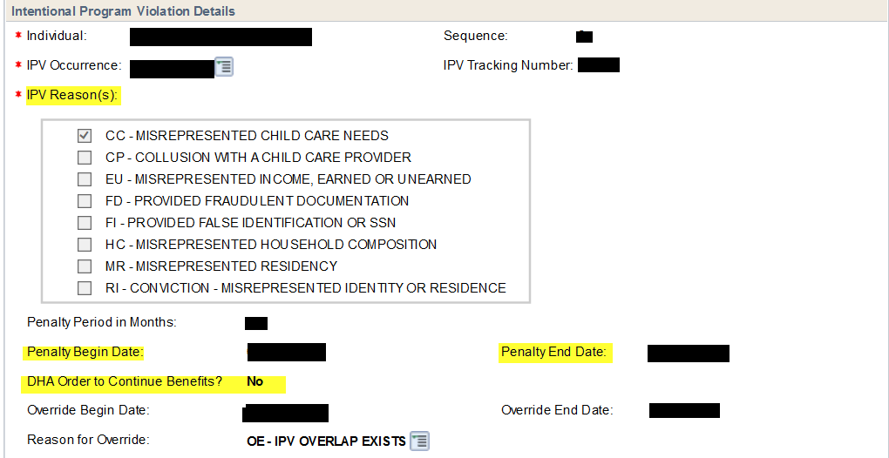
- Second IPV (2R) Overview: This section should only be completed if this is a request for a client to receive a third IPV. Please note that if you are completing this section, you must also complete the First IPV (1R) Overview. The instructions for completing this section are the same as the section above.
Summary of Investigation Findings
Provide a brief summary of the referral, reason for the investigation, and general findings of the investigation.
Example: A BRITS referral was created because the client’s current employment status was in question. Employment verification confirmed that the client ended employment with Home Improvement on 07/20/20. This information was not reported to the agency until 12/01/20. Client began employment with Health Staff on 09/30/20 and this employment ended on 10/29/20. Client reported on 03/02/21 that this employment ended and then began W2 activities on 03/11/21-06/19/21. The client was employed with Dental Duties from 05/15/21-06/16/21. Client was not in another approved activity until they began employment with Shipping Quest on 10/25/21. The client was not in approved activity with Health Staff as of 10/29/20 and failed to report to the agency they were not working during the numerous contacts they had with the agency (12/01/20 (review), 12/03/20 (question), 12/10/20 (authorization request) and 12/18/20 (provider change). It was not until the agency determined they had not been in their approved activity on 01/22/21, when they reported no longer working.

Investigation Timeline
Enter Important Dates, in sequential order, for the investigation, including:
- Child Care Authorization Dates (Begin dates and end dates)
- Dates of Contact with the Agency (any time the client should have reported a change but did not). Includes SMRFs, phone calls, etc.
- Dates of Employment (if pertinent for the case)- both begin dates and end dates
- Dates of household changes (if applicable)
- Dates of interviews/surveillance, etc.

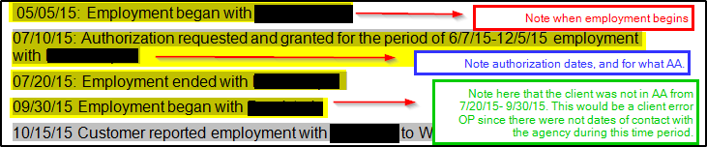
Note: It is better to provide more details here rather than lack of details. Recommendations will be returned with additional clarification questions if sufficient details are not provided.
Recommendation:
This outlines the conclusion of the investigation. This should include your final decision and why, the overpayment amount, the dates for the overpayment, and the type of program violation. Provide a brief synopsis of the evidence as well.
Example: The recommendation is to code this as an Intentional Program Violation (IPV) as the result of the client not being in an approved activity with Health Staff as of 10/29/20 and their failure to report to the agency that they were not working during numerous contacts with the agency 12/01/20 (case review), 12/03/20 (question), 12/10/20 (authorization request) and 12/18/20 (provider change). It was not until the agency determined they had not been in their approved activity on 01/22/21, when they reported no longer working. The client misrepresented their earned income/approved activity and provided fraudulent documentation. The investigation findings result in the ending of their child care benefit, and suspension from the child care program for 6 months. Total overpayment to be collected is $1234.56.

Sources of Supportive Evidence:
Please select the checkboxes for the investigative techniques that you utilized in this investigation. If you used a technique that is not listed on the form, please enter a short description in the “other” field. Enter as much information as are needed in the “other” text field.
Overpayment Results
For each overpayment discovered during the investigation, enter the following information. If more than three overpayments were discovered during this investigation, please attach a separate document with the details:
Field Descriptions
- Date Entered: If there was an agency error or client error that was discovered in tandem with an IPV overpayment, record the date the overpayment was entered into BV. If entering an overpayment related to an IPV, this field should be left blank. IPV overpayments (coded IV in BV) should not be entered until after the IPV has been approved.
- BRITS Referral Number: Enter the BRITS Referral Number that will be used/was used for the entry of the overpayment into the BV system. This may be the same number from an earlier entry, or different if a different referral was created for an overpayment creation.
Example: For the last screenshot, it was found that the client was not in their approved activity from 7/20/20-9/30/20. However, the client did not contact the agency. Thus, this is not an intentional program violation overpayment, but a client error overpayment. If the agency wanted to enter this overpayment while waiting for the IPV to be approved, they could use either the same BRITS referral number to create the claim or a separate one, if relevant. Therefore, we could have two BRITS referrals for this case: one for the client overpayment claim, and one for the IPV overpayment claim.
- Claim Number: Enter the claim number for any overpayments entered in BV from this investigation. This field only requires entry if an overpayment was created for an administrative error or client error discovered during the investigation.
- Overpayment Period: Please enter the dates for which the overpayment was calculated and relevant.
Example: For the example above, the overpayment period would be from 7/20/20-9/30/20.
- Amount: Enter the amount of the overpayment. This is a required field. Do not submit forms with this field blank or listed as “being calculated.” The IPV request will be denied until this field is complete.

Note: Client overpayment amounts can be calculated in either PLBC or PIES depending on the time of the claim. If you are adjusting the PLBC or PIES calculated overpayment, then you need to submit a Client Overpayment Worksheet.

- Error Type: From the dropdown list, select how the overpayment will be coded: AE (Administrative Error), CE (Client Error), or IV (Intentional Program Violation).
- Total Overpayment Amount: In this field, enter the total overpayment amount from the overpayment(s) documented in the rows above.
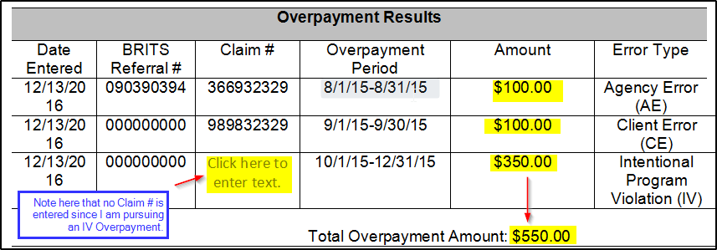

Submission
Once the form is completed, the form should be submitted to childcare@wisconsin.gov to begin the approval process.

