Overview
This is a step by step guide for an agent changing their phone number in CCA. This process changes the number CCA calls to complete the agent leg of a call (inbound and outbound calls).

Process
- Log in to CCA.
- Click on the “Configure” icon at the top right of the application.
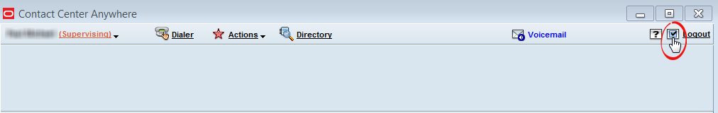
The “Configuration” window should open.
- In the Configuration window, select the “Phone” tab
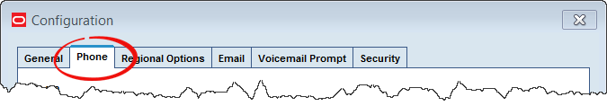
- On the phone tab, enter the new phone number in the field below the “Outside Phone (Remote Extension)” selection.
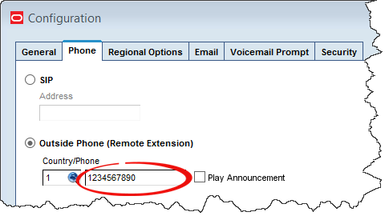

Important Notes:
The phone number entered must be:
- 10 digits
- No spaces, dashes, parentheses, etc
- A direct number to the phone used by the agent (e.g. no extensions, shared numbers, etc)
- In the Configuration window, click “OK”
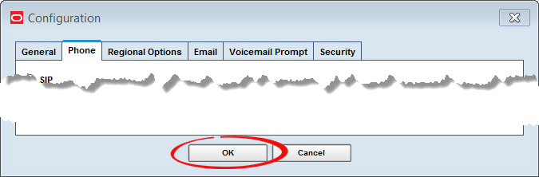
- Test the agent’s phone number using the “connect to server” function

